**Malaria species: AUC and analysis of variable contributions**

1. **Hispid starbur *(Acanthospermum hispidum)***

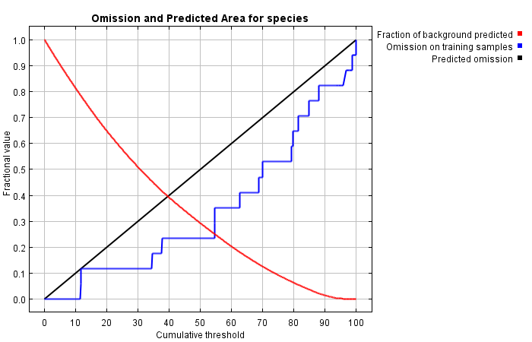

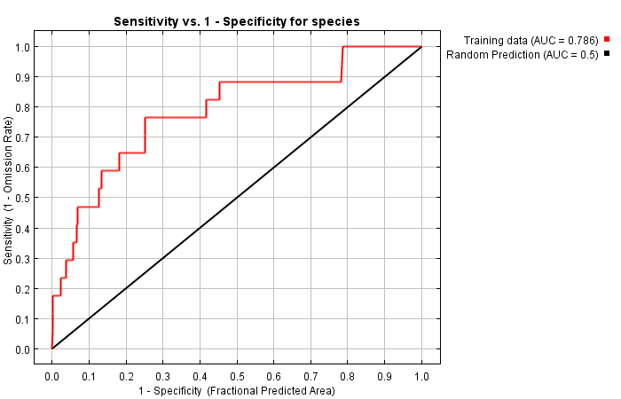

|  |  |  |  |  |
| --- | --- | --- | --- | --- |
| **Cumulative threshold** | **Cloglog threshold** | **Description** | **Fractional predicted area** | **Training omission rate** |
| 1.000 | 0.333 | Fixed cumulative value 1 | 0.980 | 0.000 |
| 5.000 | 0.352 | Fixed cumulative value 5 | 0.903 | 0.000 |
| 10.000 | 0.369 | Fixed cumulative value 10 | 0.813 | 0.000 |
| 11.568 | 0.372 | Minimum training presence | 0.786 | 0.000 |
| 11.712 | 0.372 | 10 percentile training presence | 0.784 | 0.059 |
| 54.548 | 0.590 | Equal training sensitivity and specificity | 0.252 | 0.235 |
| 54.548 | 0.590 | Maximum training sensitivity plus specificity | 0.252 | 0.235 |
| 0.023 | 0.309 | Balance training omission, predicted area and threshold value | 1.000 | 0.000 |
| 10.501 | 0.370 | Equate entropy of thresholded and original distributions | 0.805 | 0.000 |

**Analysis of variable contributions**

|  |  |  |
| --- | --- | --- |
| **Variable** | **Percent contribution** | **Permutation importance** |
| simplelc2000 | 68.7 | 61.1 |
| gpw2000_30_sec | 28.7 | 8.7 |
| bio4 | 2.5 | 30.2 |
| bio16 | 0 | 0 |

1. **Nigerian powder-flask fruit *(Afraegle paniculate)*** 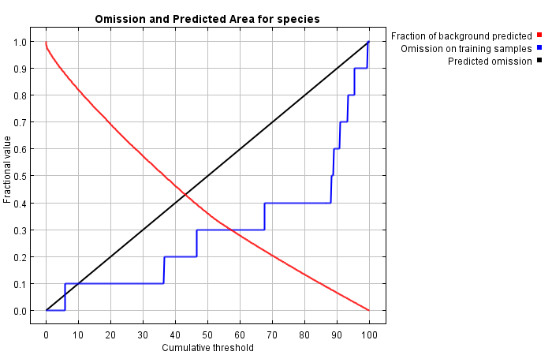

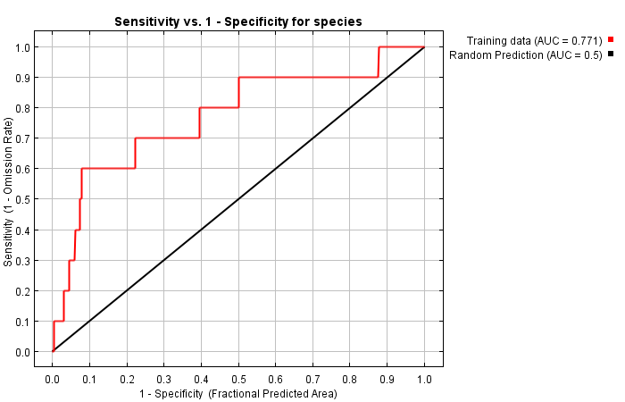

|  |  |  |  |  |
| --- | --- | --- | --- | --- |
| **Cumulative threshold** | **Cloglog threshold** | **Description** | **Fractional predicted area** | **Training omission rate** |
| 1.000 | 0.363 | Fixed cumulative value 1 | 0.959 | 0.000 |
| 5.000 | 0.459 | Fixed cumulative value 5 | 0.891 | 0.000 |
| 10.000 | 0.500 | Fixed cumulative value 10 | 0.819 | 0.100 |
| 5.908 | 0.466 | Minimum training presence | 0.877 | 0.000 |
| 36.428 | 0.575 | 10 percentile training presence | 0.502 | 0.100 |
| 57.227 | 0.703 | Equal training sensitivity and specificity | 0.300 | 0.300 |
| 88.145 | 0.754 | Maximum training sensitivity plus specificity | 0.078 | 0.400 |
| 0.474 | 0.311 | Balance training omission, predicted area and threshold value | 0.971 | 0.000 |
| 2.058 | 0.416 | Equate entropy of thresholded and original distributions | 0.939 | 0.000 |

**Analysis of variable contributions**

|  |  |  |
| --- | --- | --- |
| **Variable** | **Percent contribution** | **Permutation importance** |
| simplelc2000 | 60.3 | 40.1 |
| gpw2000_30_sec | 38.5 | 46.9 |
| bio16 | 1.2 | 12.9 |
| bio4 | 0 | 0 |
|  |  |  |

1. **Grains of paradise *(Aframomum melegueta)***

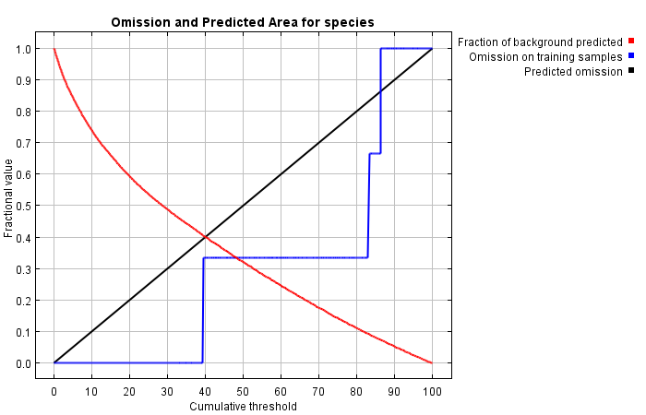

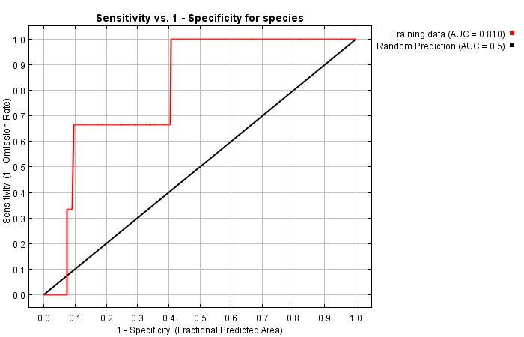

|  |  |  |  |  |
| --- | --- | --- | --- | --- |
| **Cumulative threshold** | **Cloglog threshold** | **Description** | **Fractional predicted area** | **Training omission rate** |
| 1.000 | 0.208 | Fixed cumulative value 1 | 0.960 | 0.000 |
| 5.000 | 0.314 | Fixed cumulative value 5 | 0.842 | 0.000 |
| 10.000 | 0.376 | Fixed cumulative value 10 | 0.738 | 0.000 |
| 39.366 | 0.654 | Minimum training presence | 0.406 | 0.000 |
| 39.366 | 0.654 | 10 percentile training presence | 0.406 | 0.000 |
| 48.378 | 0.677 | Equal training sensitivity and specificity | 0.334 | 0.333 |
| 39.366 | 0.654 | Maximum training sensitivity plus specificity | 0.406 | 0.000 |
| 4.184 | 0.297 | Balance training omission, predicted area and threshold value | 0.863 | 0.000 |
| 3.519 | 0.284 | Equate entropy of thresholded and original distributions | 0.880 | 0.000 |

**Analysis of variable contributions**

|  |  |  |
| --- | --- | --- |
| **Variable** | **Percent contribution** | **Permutation importance** |
| bio4 | 100 | 100 |
| simplelc2000 | 0 | 0 |
| gpw2000_30_sec | 0 | 0 |
| bio16 | 0 | 0 |

1. ***Afrostyrax lepidophyllus***

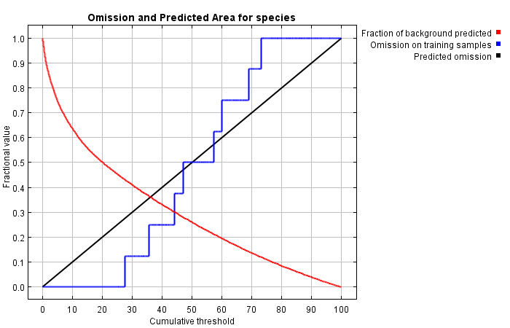

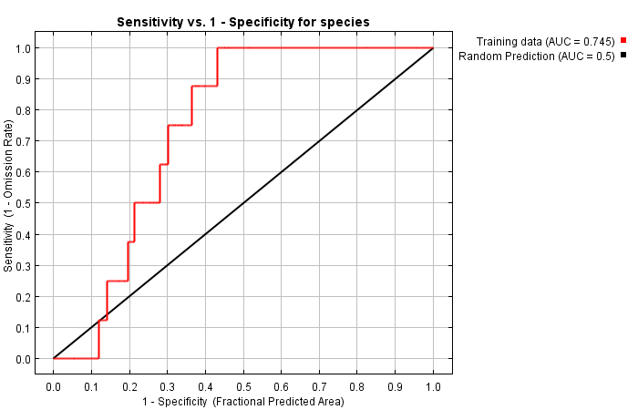

|  |  |  |  |  |
| --- | --- | --- | --- | --- |
| **Cumulative threshold** | **Cloglog threshold** | **Description** | **Fractional predicted area** | **Training omission rate** |
| 1.000 | 0.107 | Fixed cumulative value 1 | 0.912 | 0.000 |
| 5.000 | 0.224 | Fixed cumulative value 5 | 0.745 | 0.000 |
| 10.000 | 0.346 | Fixed cumulative value 10 | 0.635 | 0.000 |
| 27.540 | 0.590 | Minimum training presence | 0.431 | 0.000 |
| 27.540 | 0.590 | 10 percentile training presence | 0.431 | 0.000 |
| 44.153 | 0.660 | Equal training sensitivity and specificity | 0.301 | 0.250 |
| 27.540 | 0.590 | Maximum training sensitivity plus specificity | 0.431 | 0.000 |
| 6.069 | 0.266 | Balance training omission, predicted area and threshold value | 0.717 | 0.000 |
| 4.230 | 0.206 | Equate entropy of thresholded and original distributions | 0.772 | 0.000 |

**Analysis of variable contributions**

|  |  |  |
| --- | --- | --- |
| **Variable** | **Percent contribution** | **Permutation importance** |
| bio4 | 100 | 100 |
| simplelc2000 | 0 | 0 |
| gpw2000_30_sec | 0 | 0 |
| bio16 | 0 | 0 |

1. **African Mahogany *(Afzelia africana***

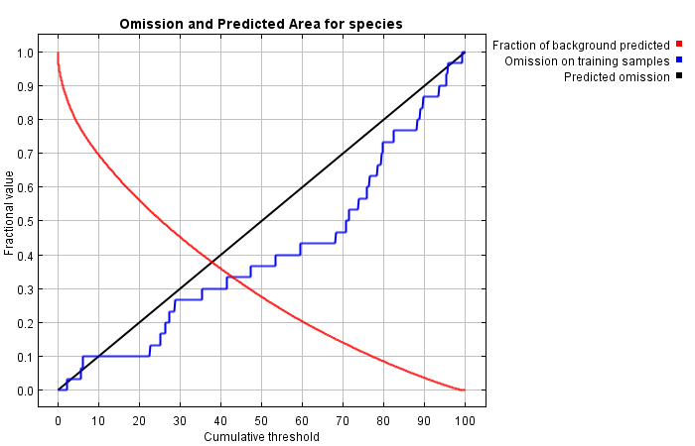

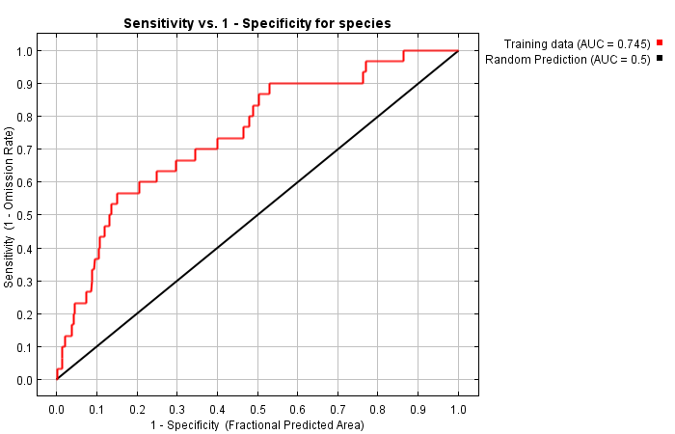

|  |  |  |  |  |
| --- | --- | --- | --- | --- |
| **Cumulative threshold** | **Cloglog threshold** | **Description** | **Fractional predicted area** | **Training omission rate** |
| 1.000 | 0.155 | Fixed cumulative value 1 | 0.906 | 0.000 |
| 5.000 | 0.309 | Fixed cumulative value 5 | 0.784 | 0.033 |
| 10.000 | 0.408 | Fixed cumulative value 10 | 0.695 | 0.100 |
| 2.080 | 0.208 | Minimum training presence | 0.864 | 0.000 |
| 22.542 | 0.513 | 10 percentile training presence | 0.531 | 0.100 |
| 43.011 | 0.613 | Equal training sensitivity and specificity | 0.333 | 0.333 |
| 68.164 | 0.736 | Maximum training sensitivity plus specificity | 0.151 | 0.433 |
| 2.080 | 0.208 | Balance training omission, predicted area and threshold value | 0.864 | 0.000 |
| 4.020 | 0.277 | Equate entropy of thresholded and original distributions | 0.807 | 0.033 |

**Analysis of variable contributions**

|  |  |  |
| --- | --- | --- |
| **Variable** | **Percent contribution** | **Permutation importance** |
| bio16 | 57.5 | 56.4 |
| bio4 | 23.4 | 38.2 |
| simplelc2000 | 16.8 | 4.7 |
| gpw2000_30_sec | 2.3 | 0.6 |

1. **Chick weed (*Ageratum conyzoides)***

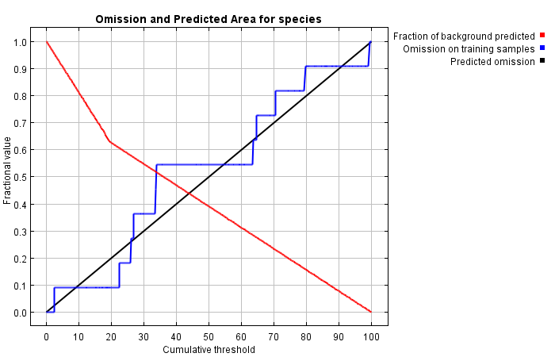

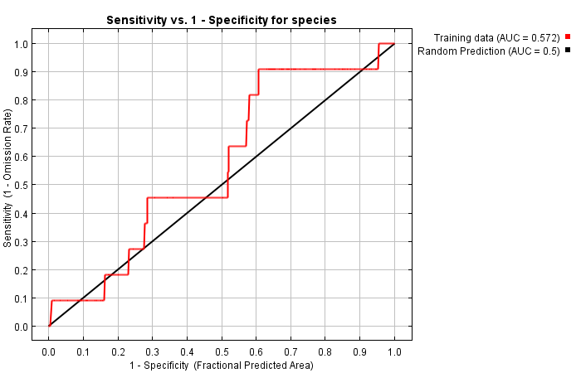

|  |  |  |  |  |
| --- | --- | --- | --- | --- |
| **Cumulative threshold** | **Cloglog threshold** | **Description** | **Fractional predicted area** | **Training omission rate** |
| 1.000 | 0.389 | Fixed cumulative value 1 | 0.980 | 0.000 |
| 5.000 | 0.389 | Fixed cumulative value 5 | 0.904 | 0.091 |
| 10.000 | 0.389 | Fixed cumulative value 10 | 0.810 | 0.091 |
| 2.415 | 0.389 | Minimum training presence | 0.955 | 0.000 |
| 22.331 | 0.696 | 10 percentile training presence | 0.607 | 0.091 |
| 33.893 | 0.696 | Equal training sensitivity and specificity | 0.517 | 0.545 |
| 22.331 | 0.696 | Maximum training sensitivity plus specificity | 0.607 | 0.091 |
| 0.026 | 0.387 | Balance training omission, predicted area and threshold value | 1.000 | 0.000 |
| 3.875 | 0.389 | Equate entropy of thresholded and original distributions | 0.927 | 0.091 |

**Analysis of variable contributions**

|  |  |  |
| --- | --- | --- |
| **Variable** | **Percent contribution** | **Permutation importance** |
| simplelc2000 | 99.9 | 100 |
| gpw2000_30_sec | 0.1 | 0 |
| bio4 | 0 | 0 |
| bio16 | 0 | 0 |

1. **Christmas bush *(Alchornea cordifolia)***

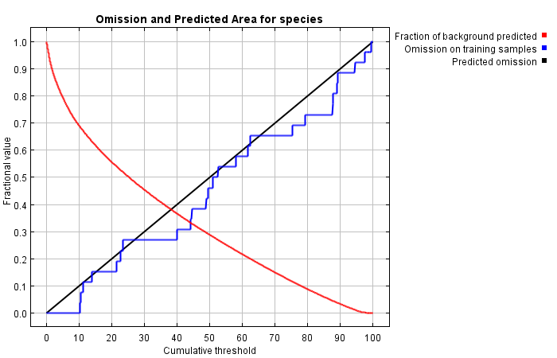

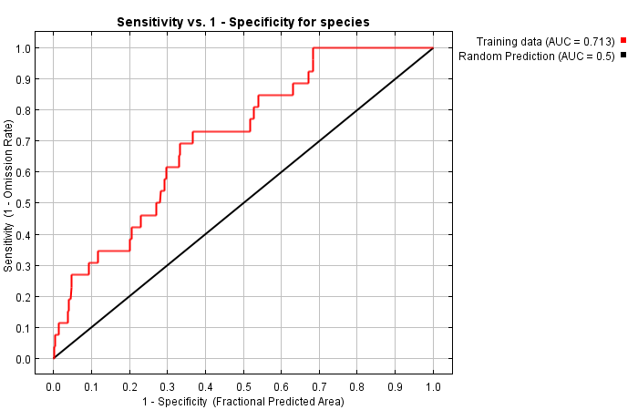

|  |  |  |  |  |
| --- | --- | --- | --- | --- |
| **Cumulative threshold** | **Cloglog threshold** | **Description** | **Fractional predicted area** | **Training omission rate** |
| 1.000 | 0.127 | Fixed cumulative value 1 | 0.932 | 0.000 |
| 5.000 | 0.271 | Fixed cumulative value 5 | 0.793 | 0.000 |
| 10.000 | 0.401 | Fixed cumulative value 10 | 0.690 | 0.000 |
| 10.301 | 0.405 | Minimum training presence | 0.685 | 0.000 |
| 11.179 | 0.415 | 10 percentile training presence | 0.671 | 0.077 |
| 44.193 | 0.643 | Equal training sensitivity and specificity | 0.333 | 0.346 |
| 39.910 | 0.625 | Maximum training sensitivity plus specificity | 0.367 | 0.269 |
| 5.318 | 0.275 | Balance training omission, predicted area and threshold value | 0.785 | 0.000 |
| 4.412 | 0.257 | Equate entropy of thresholded and original distributions | 0.809 | 0.000 |

**Analysis of variable contributions**

|  |  |  |
| --- | --- | --- |
| **Variable** | **Percent contribution** | **Permutation importance** |
| bio4 | 76.3 | 73 |
| gpw2000_30_sec | 19.8 | 10.2 |
| simplelc2000 | 3.8 | 16.8 |
| bio16 | 0 | 0 |